**S. Y. B. Tech (ECE)**

**Trimester: V Subject:** Integrated Circuits and Applications

**Name: Shreerang Mhatre Class: SY B. Tech Electrical and Computer**

**Roll No: 29 Batch: A2**

**Experiment No: 08**

**Name of the Experiment:** Design and build 1st order Low pass & High pass Active filters for given specifications.

**Marks**

**Teacher’s Signature with date**

**Performed on: 21/11/2022**

**Submitted on: 1/12/22**

**Aim:** To study performance and frequency response of $1^{st}$ order Low pass & High pass Active filters   
**Pre-requisite:** Op-Amp Inverting and Non-Inverting Mode Configuration.

**Objectives:**

* To observe the frequency response for the designed cutoff frequency
* To measure the pass band gain, stop band gain with respect to cutoff frequency
* To observe input and output waveforms

**Components and equipment required:**

Bread Board, IC LF356, Oscilloscope, Function generator, Dual power supply

**Theory:**

A filter is a frequency selective circuit that passes a specified band of frequencies and blocks or attenuates signals of frequencies outside this band. Filter may be classified on a number of ways.

1. Analog or digital
2. Passive or active
3. Audio or radio frequency

Analog filters are designed to process only signals while digital filters process analog signals using digital technique. Depending on the type of elements used in their consideration, filters may be classified as passive or active.

Elements used in passive filters are resistors, capacitors and inductors. Active filters, on the other hand, employ transistors or Op-Amps, in addition to the resistor and capacitors. Depending upon the elements the frequency range is decided.

RC filters are used for audio or low frequency operation. LC filters are employed at RF or high frequencies. The most commonly used filters are these:

1. Low pass filters
2. High pass filter
3. Band pass filter
4. Band reject filter.
5. All pass filter

The Figure 7.1 illustrates frequency response characteristics of the five types of filter. The ideal response is shown by dashed line, while the solid line indicates the practical filter response.

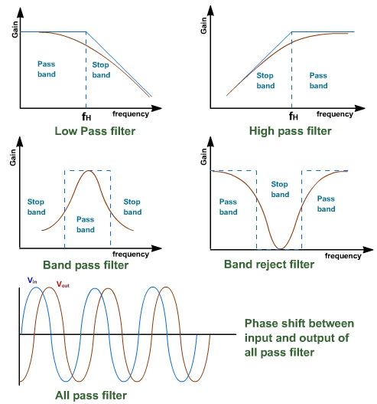

**Figure 7.1: Different Frequency Response of Filters**

Active filters are a group of electronic filters that utilizes active components like an amplifier for its functioning. Amplifiers are used in filters for designing to enhance the predictability and performance.

**Advantages of Active filters**:

1) **Gain and frequency adjustment in active filters**. In passive filters, the signal which is applied as input is attenuated. But in active filters amplification can be achieved with the help of Op-amp. Another advantage is the flexibility in frequency adjustment.

2) **No loading effect**: The source and load offers loading to the device because of which input is reduced at the source as well as reduced output at the load.

3) **Cheap** .The op-amp is cheap and implementation is easy with Op-Amps.

**Disadvantages of Active filters:**

1. Active devices need power supply for operation.
2. Slew rate of Op-Amp can put a limit on frequency of operation.

**Active low pass filter with pass band gain voltage gain:**

A first-order (single-pole) **Active Low Pass Filter** as shown in Figure 7.2 as its name implies, attenuates high frequencies and passes low frequency signals. It consists simply of a passive filter section followed by a non-inverting operational amplifier. The frequency response as shown in Figure 7.3 of the circuit is the same as that of the passive filter, except that the amplitude of the signal is increased by the gain of the amplifier and for a non-inverting amplifier the value of the pass band voltage gain is given as (1 + Rf/R1).

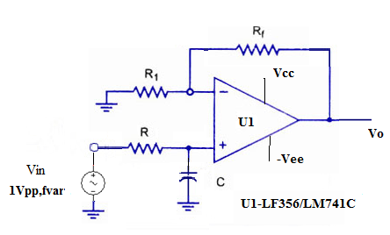

**Figure 7.2: Active Low Pass 1st order Filter**

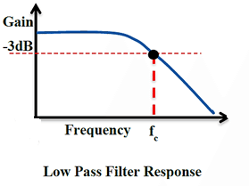

**Figure 7.3: Response of Active low Pass 1st order Filter**

**Active High Pass Filter**

A first-order (single-pole) **Active High Pass Filter** as shown in Figure 7.4 as its name implies, attenuates low frequencies and passes high frequency signals. It consists simply of a passive filter section followed by a non-inverting operational amplifier. The frequency response as shown in Figure 7.5 of the circuit is the same as that of the passive filter, except that the amplitude of the signal is increased by the gain of the amplifier and for a non-inverting amplifier the value of the pass band voltage gain is given as 1 + Rf/R1, the same as for the low pass filter circuit.

**Active High Pass Filter with Amplification**

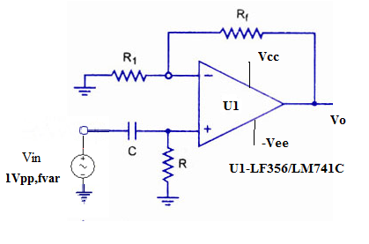

**Figure 7.4: Active High Pass 1st order Filter**

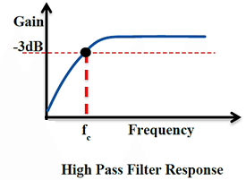

**Figure 7.5: Response of Active High Pass 1st order Filter**

**Cascading of Filters**:

In order to obtain a sharp response with a passive filter, we would need to cascade several passive stages. Higher-order high pass active filters, such as third, fourth, fifth, etc. are formed simply by cascading together first and second-order filters as shown in Figure 7.6. For example, a third order high pass filter is formed by cascading in series first and second order filters, a fourth-order high pass filter by cascading two second-order filters together and so on.

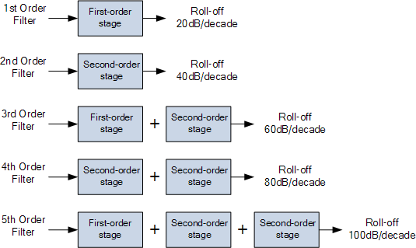

**Figure 7.6: Cascading Higher Order Filters**

The most common types of active filters are classified depending on the alignment curve as shown in Figure 7.7 for pass band and stop band in the following categories.

* Butterworth
* Chebyshev
* Bessel
* Elliptical

  There are various kinds of filters are available, but most of the applications can be resolved with these implementations.

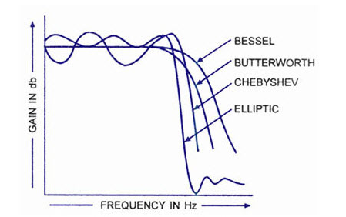

**Figure 7.7: Comparison of alignment curves for filter design**

**Procedure:**

1) Make the connections as shown in circuit diagram.

2) Apply +Vcc=12V and -Vcc= -12V.

3) Apply Vin as 1Vpp and vary the frequency.

4) Observe and draw the output waveform.

5) Calculate pass band gain and find out cut off frequency.

6) Observe the waveforms at the output and sketch the same.

**Design Steps:**

1. Refer Figure 7.2 for 1st order Low pass Filter design and Figure 7.4 for 1st order High pass Filter design.
2. For a given cut off frequency $f_{c}$ say 1.5 Khz, assume C=0.1uF.
3. Calculate R from formula mentioned below
$f_{c}$ $=\frac{1}{2πRC}$

5. Here R =1.06 K by design, so choose R= 1Kohms
6. Assume pass band gain=2
7. Non Inverting Configuration gain is given by 1+ Rf /R1= 2 ,so R1=Rf=10Kohms

**Observation Table for Frequency Response LPF:**

|  |  |  |
| --- | --- | --- |
| **Frequency (Hz)** | **Output Voltage (V)** | **Gain in db** |
| 300 Hz | 5 V | 13.97 |
| 500 Hz | 5 V | 13.97 |
| 600 Hz  1 | 5 V | 13.97 |
| 1000 Hz | 4.6 V | 13.25 |
| 1.5 KHz | 3.4 V | 10.62 |
| 2 KHz | 3.2 V | 10.103 |
| 5 KHz | 2 V | 6.02 |
| 10 KHz | 1.4 V | 2.92 |
| 20 KHz | 0.6 V | -4.43 |
| 50 KHz | 0.4 V | -7.9 |
|  |  |  |
|  |  |  |
|  |  |  |
|  |  |  |
|  |  |  |
|  |  |  |
|  |  |  |
|  |  |  |
|  |  |  |

**Observation Table for Frequency Response-HPF**

|  |  |  |
| --- | --- | --- |
| **Frequency (Hz)** | **Output Voltage (V)** | **Gain in db** |
| 200 | 0.58 | -4.73 |
| 500 | 1.02 | 0.17 |
| 700 | 1.7 | 4.6 |
| 1000 | 2.3 | 7.23 |
| 1300 | 2.71 | 8.65 |
| 1500 | 3.02 | 9.6 |
| 2000 | 3.6 | 11.12 |
| 3000 | 4.22 | 12.50 |
| 4000 | 4.53 | 13.12 |
| 8000 | 4.96 | 13.9 |
|  |  |  |
|  |  |  |
|  |  |  |
|  |  |  |
|  |  |  |
|  |  |  |
|  |  |  |
|  |  |  |
|  |  |  |

**Conclusion: Thus we have studied the performance and frequency response of $1^{st}$ order Low pass & High pass Active filters.**

**Post Lab Questions**:

1. Why prefer active filter over passive filters?
2. What is loading effect?
3. What is insertion loss?

**Additional links for more information:**

https://nptel.ac.in/courses/117107094/15

https://www.elprocus.com/types-active-filters-and-applications

